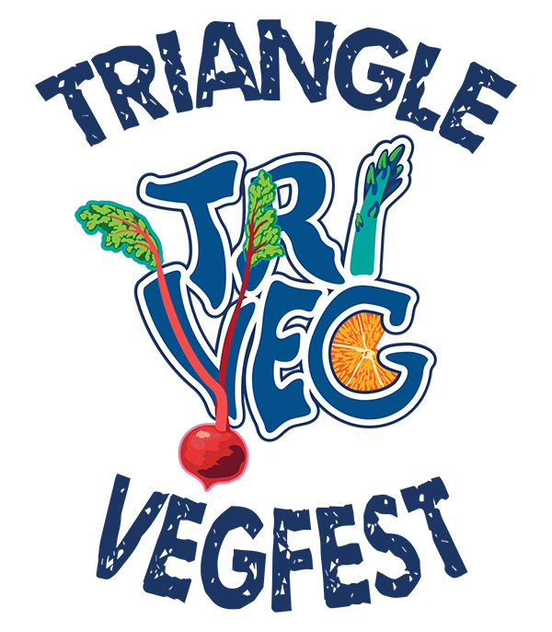

2014 Business Report

Created by Alexandria Lane

Table of Contents

About…………………………………………………………………………………………………………3
Vendors……………………………………………………………………………………………………..5
Speakers…………………………………………………………………………………………………….7
Sponsors…………………………………………………………………………………………………….8
Social Media & Advertising………………………………………………………………………….10
Attendees…………………………………………………………………………………………………..12
Media…………………………………………………………………………………………………….....13
2015 Projections…………………………………………………………………………………………14
Special Thanks……………………………………………………………………………………………15

About the 2014 Triangle Vegfest

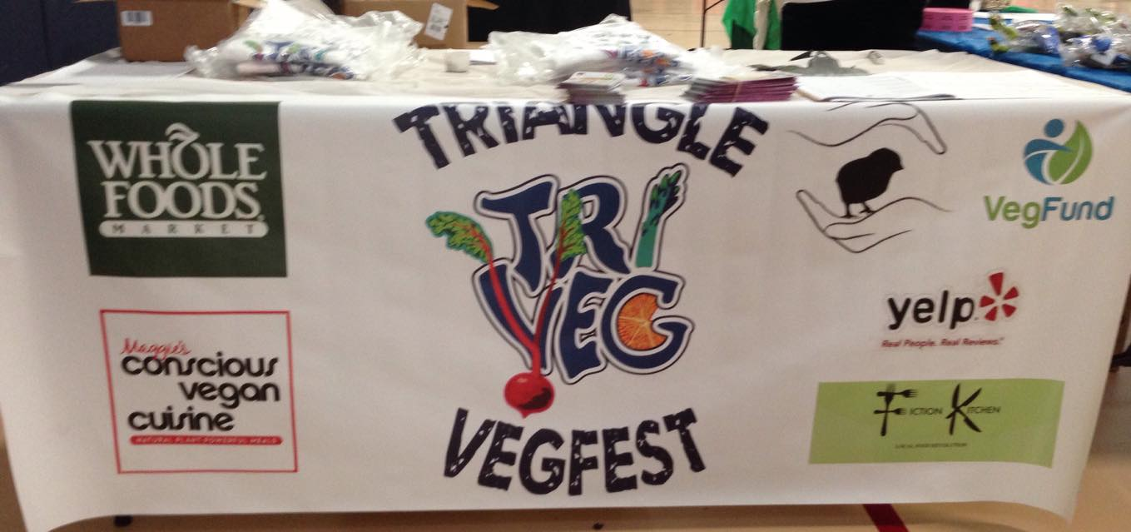
ABOUT

The inaugural Triangle Vegfest was an amazing success. Conceived, planned, organized and launched in just four months, the 2014 Triangle Vegfest exceeded expectations on every level.

The goal of the 2014 Triangle Vegfest was to celebrate healthy living through plant-based lifestyles and to bring together a community while introducing Triangle-area citizens to the variety of veg-friendly food, goods, and services available in the Raleigh Metro area. While the entire festival was vegan, vegetarians and omnivores were encouraged to attend.

The Triangle Vegfest, presented by Piedmont Farm Animal Refuge, was conceived of and organized by Helene Greenberg with help from Alex Lane and a team of planning committee members including, Maitri Acharya, Jen Morris, Janina Knobeloch, Dave Baldwin, and many others. On the day of the event, 20 volunteers also gave their assistance with set up, take down, and maintaining order.

In addition to dozens of vendors, the 2014 Triangle Vegfest also featured 6 speakers and a variety of interactive events throughout the day including free massages, yoga, tai chi classes, live music, and cooking demonstrations.
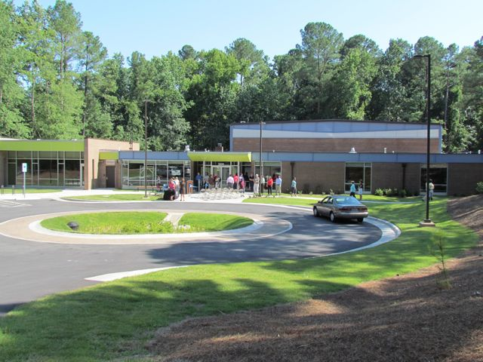

DATE AND TIME

October 19, 2014
12 to 5 p.m.

LOCATION

Carolina Pines Community Center
2305 Lake Wheeler Road
Raleigh, North Carolina

The location offered both indoor and outdoor space, which was ideal.

The indoor gym was the focal point of the event, showcasing half of the vendors, food demonstrations, and the Triangle Vegfest and Piedmont Farm Animal

We used a large side room with projector and audiovisual capabilities for the speaker series. A smaller side room housed yoga classes, massages, and tai chi demonstrations.

The indoor area also had ample bathroom space with 6 women’s and 6 men’s stalls.

A majority of the food vendors set up outside; several vendors were required to use the outdoor space because they were cooking with an open flame. Attendees were able to dine in a covered picnic area with live music nearby.

LESSONS LEARNED - ORGANIZATION

The success of 2014 Triangle Vegfest speaks to the potential this event has to promote aware and advance the community of people committed to healthy, plant-based lifestyles. Triangle Vegfest organizers are committed to making this an annual event. Reflection on successes and lessons learned, along with a preview of next year’s Triangle Vegfest are below:

PLANNING ISSUES:

Problem | Proposed Solution
- Limited planning time (4 months before the event) curtailed the number and nature of ideas that could be implemented | - External personal and professional commitments interfered with the effectiveness of the small planning committee.  - Convene planning committee in January 2015, allowing 10 months to research and fully develop ideas and contacts.  - Expand the planning committee to be at least two people deep in major planning areas.
Goal for 2014 Triangle Vegfest Planning – Involving more committee members and having a longer planning period will improve upon the planning process.

LOCATION ISSUES:

While the Carolina Pines Community Center was an ideal location for an inaugural festival, there were issues that suggest that alternative sites should be considered for an event that is expected to double in size.

Many vendors needed access to electricity, but electrical outlets were few and far between. We were able to overcome this by repositioning vendors and providing multiple extension cords, but it was difficult.

Even though the gym neared a capacity crowd several times during the festival, a layout that pushed vendors to the walls and left the center open meant that the space often felt open, empty or underused. The 2015 Triangle Vegfest will better space vendors to accommodate and spread foot traffic.

Parking at the Carolina Pines Community Center was limited. There are two lots at the community center, a small 60-space lot near the facility and a large lot on the opposite side of the facility. At the height of the festival, many attendees were confused about where to park. Some of those who reached the large lot created an extra row of parking spaces. Though there was no charge for parking, some neighborhood children tried to solicit money for parking until a Carolina Pines Community Center staff member removed the young entrepreneurs. At the 2015 Triangle Vegfest, signs will clearly point guests to parking spaces, and the fact that parking is free will be prominently noted.

Ideas for the location of the 2015 Triangle Vegfest include Marbles Kids Museum, the Red Hat Amphitheater, the Museum of Art, and Moore Square in Raleigh, North Carolina.
Vendors

The 2014 Triangle Vegfest had: 16 food vendors, 11 organizations providing goods and services and six nonprofit organizations.
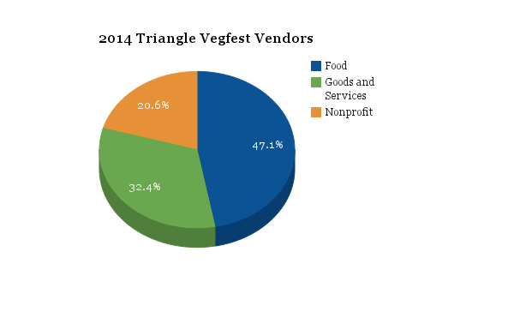
United Poultry Concerns | Whole Foods Market | Ninth Street Bakery | Triangle Vegetarian Society
Piedmont Farm Animal Refuge | Triangle Chance for All | Ecolicious | Farm Sanctuary
Spread | Maggie’s Conscious Vegan Cuisine | Liz Lovely | The Vegan Lover
Yelp | Shorganics | Rescue Chocolate | Delight Soy
Joie de Vegan | The Humane League | Fiction Kitchen | Dogtopia
Roots Hummus | Humane Carolina | Shaklee | Tempeh Girl
doTerra | Green Smoothie Girl | Qigong Institute of Healing and Wellness | Nourish
Cloud Massage | Juvn8 Smoothies | Yugala’s Kitchen | Chinese Shao-Lin Center of Raleigh
 | Vegan Beauty Boutique | Triangle Pranic Healing
Nonprofits paid $150 for a space, while for-profit vendors paid $200. Those signing up by August 31 received a $50 early-bird discount. Vendors could access electricity for an extra $25.

In general, vendors could choose an indoor space or an outdoor space. Vendors cooking with open flame were required, per the regulations of the community center, to set up outside.

Vendors who also signed up as sponsors were provided with tables, chairs, and tents.

Vendors were assigned start times to begin setup the day of the festival. All vendors were required to finish setup by 11:30 a.m., ahead of the event’s noon start.

LESSONS LEARNED – VENDOR PERCEPTIONS

We send a survey to all vendors shortly after the 2014 Triangle Vegfest. Fifteen of the vendors responded. The organizers agreed with almost all of the comments made by the vendors and hope to implement their suggestions for the 2015 Triangle Vegfest.

Vendors rated the festival a 4.53 out of 5 where 5 was the best and 1 was the worst. Most vendors felt that the pricing was fair, and all but two said that they would definitely participate in the 2015 Triangle Vegfest. The other two weren’t able to give a definite commitment.

The vendors overwhelmingly praised the energy of the event, the ease of set up, and the helpfulness of the volunteers.

Vendors interest in making Triangle Vegfest a stronger event is reflected in how engaged they were in offering welcomed suggestions for improvement including:

- Having a better media plan
- More garbage, compost, and recycling
- Having more vendors with beverages
- Music was too loud
- Increased signage
- Assigned spaces for vendors
- More vendors and food vendors
- Having vendors commit to stay the entire time
- Having an ATM on site

Many vendors ran out of food and goods, some as early as 1:30 p.m.
With regards to the 2015 Triangle Vegfest, four out of five vendors felt that a location with both indoor and outdoor areas was ideal. Most also said that Fall was an optimal time of the year for a festival. The vendors were split on whether or not alcohol should be included at the 2015 Triangle Vegfest.

Speakers

The 2014 Triangle Vegfest featured 6 speakers ranging from nationally-recognized animal advocates to local vegan activists. The speaker room had audiovisual capacity for the presentations. Each speaker was given 40 minutes in which to present and answer questions.

Dilip Barman, president of the Triangle Vegetarian Society, was the first speaker. He spoke about the virtues of vegetarianism for animals and health.

Gene Baur, founder and president of Farm Sanctuary, was the keynote speaker. There was standing room only for his talk (about 150 attendees). He spoke about Farm Sanctuary, animal refuge, and veganism. Gene Baur did require a speaker donation of $1,000 to Farm Sanctuary. This cost was covered with an exclusive dinner which was held at Fiction Kitchen the night before the festival. Tickets were $100 each with 12 people attending the “intimate night with Gene Baur.”

Kathy Hester, author of the blog Healthy Slow Cooking, stepped in at the last minute after two speakers fell through. In addition to conducting food demonstrations throughout the day, she gave a presentation about cooking easy, healthful vegan meals.

Karen Davis, PhD, founder of United Poultry Concerns, gave a presentation about the individuality of chickens.

Erin Fergus, vegan bodybuilder and found of Definition for Ladies, spoke about health vegan bodies including how veganism helped her to overcome her eating disorder.

Justin Van Kleeck, president of Triangle Chance for All and co-founder of the Microsanctuary Movement, held a conversation about microsanctuaries and how small-scale farmed animal rescue is an accessible way for vegans to engage directly with animals and their community.

LESSONS LEARNED - SPEAKERS

While most of the talks were well attended, not all were. Several speakers wished that they had longer to talk, though the venue of a festival does not lend itself to extensive discussions. For the 2015 Triangle Vegfest we may have fewer speakers to allow for extended talks. More announcements will be made during the event itself announcing each speaker. The organizers will also ensure that speaker times and themes are listed on the website and social media further in advance.

Sponsors

FINANCIAL SPONSORS

The 2014 Triangle Vegfest had 6 financial sponsors. There were three levels of sponsorship: Golden Beet Level ($1,500), Silverbeet Level ($1,000), and the Bronze Fennel Level($500). Sponsors’ names and logos were included on promotional materials and on the website. The higher-level sponsors were also given priority spaces at the festival and were provided tables and chairs. The festival was “presented by” Piedmont Farm Animal Refuge. This sponsorship allowed for tax-deductible donations to be made to the Triangle Vegfest. Piedmont Farm Animal Refuge was also given space next to the front entrance of the gym for maximum exposure indoors.

Whole Foods provided sponsorship at the highest rate and also provided food for the dinner with Gene Baur at Fiction Kitchen. As a vendor, Whole Foods sampled a new vegan cheese and provided activities for children.

Maggie’s Conscious Vegan Cuisine also provided a high-level sponsorship. Maggie’s sold their meals at the festival at a reduced rate. Attendees were delighted to find a quick heat-to-eat vegan meal. Maggie’s, in particular, provided valuable feedback to the organizers.

Vegfund, a vegan nonprofit that provides money for food-based vegan outreach, provided a high-level sponsorship. Vegfund require an application in addition to a follow up report with pictures.

Yelp provided sponsorship and set up a table at the event. Yelp introduced people to their app and allowing attendees to voice their opinions about the vendors and the vegfest itself. Yelp was also promoted the 2014 Triangle Vegfest on social media sites.

Fiction Kitchen, was an in-kind sponsor for their help putting on the fundraising dinner with Gene Baur.

IN-KIND DONATIONS

In addition to financial sponsors, the 2014 Triangle Vegfest received in-kind donations of coupons and promotional material from 11 national vegan vendors:

Follow Your Heart | V-Dog | Gardein
Herbivore | Beyond Meat | Go Veggie
Upton’s Naturals | Liz Lovely | Brad’s Raw Crunchy Kale
Rescue Chocolate | Daiya

These in-kind donations were used to create 300 goody bags which were given to the first 300 attendees. The bags were very popular with attendees requesting bags well after they had all been given away. The volunteers giving out bags also provided a very welcoming introduction to the festival.

LESSONS LOEARNED – FINANCE

The financial sponsors, as a whole, seemed very pleased with the turnout at the festival and with the acknowledgment that they received for helping to create the event. However, the sponsorship levels were intended to differentiate between the vendors, but this ended up not meaning much. The Triangle Vegfest may need to reevaluate the sponsorship levels to include more important distinctions between the levels, or eliminate the levels altogether.

The goody bags were a huge hit with attendees, and the coupons will certainly help introduce people to new vegan foods. For next year, more national vendors will be solicited for in-kind donations. A greater number of goody bags will be created, probably around 500. Additionally, stuffing the bags was a time-consuming and physically demanding job. More volunteers will be needed in the creation of the goody bags for the 2015 Triangle Vegfest.

Rescue Chocolate contributed by selling chocolates at a reduced price to the Triangle Vegfest. The Vegfest then sold the chocolates at the festival where they sold out. For the 2015 Triangle Vegfest, a greater amount of chocolate may be purchased and sold.

The Triangle Vegfest planning committee will consider applying for their own tax-exempt 501c3 status for 2015.

Social Media and Advertising

SOCIAL MEDIA

The 2014 Triangle Vegfest had both a group and a page on Facebook. By the time of the festival, the page had around 750 likes. Additionally, the Triangle Vegfest has a Twitter account and an Instagram account.

The Triangle Vegfest website was created by Alex Lane and hosted on Bluehost using Wordpress. The website host cost $100 plus $15 for the URL, www.TriangleVegfest.com. The website was updated as needed with information about new vendors, sponsors, and speakers. In the month of October the website had 10,160 page views from 3,095 web users.

Fifty dollars in free Facebook advertising was included in the Bluehost hosting package. Two Facebook ads were run in October for the full $50 amount and these campaigns garnered 102 page likes and 2,457 people reached.

Advertising

The event was put on 11 Triangle-area events calendars. Additionally, 500 flyers were distributed throughout the Triangle. The price to print full color flyers glossy paper was $328.22.

LESSONS LEARNED – PROMOTIONAL MEDIA

The Facebook advertising had an excellent return on investment with 13.2 percent of the total page “likes” coming directly from the Facebook ads. The website also had a lot of traffic leading up to the day of the event. Twitter was an effective way to reach out to national vendors.

The planning committee tried to post daily on all social media sites, but this did not always happen. Some vendors and sponsors were not posted on social media in the weeks leading up to the event, which meant the planning committee had to scramble to post content about these missing vendors and sponsors the week of the event. For the 2015 Triangle Vegfest, vendors, sponsors and speakers will be posted on social media in a more timely and thorough manner using an internal calendar.

It is confusing to have both a Facebook group and a Facebook page. The planning committee will consider making the group a “closed group” for planning activities for the 2015 Triangle Vegfest.

The organizers will also devote more money to traditional advertising in newspapers and on the radio and will pursue these outlets’ public service announcements as a more cost-effective option.

Attendees

The 2014 Triangle Vegfest had between 1,500 and 2,000 attendees as estimated by a news reporter. The volunteers at the 2014 Triangle Vegfest conducted informal verbal surveys, and the attendees had heard about the festival through a variety of media. Since no formal survey was conducted, demographics are about the Facebook page likes.

The Triangle Vegfest Facebook page, at the time of the event, had 770 likes. Women made up 80 percent of the likes on the page, however, this gender gap was not seen as prominently at the festival itself. This may suggest that women are more likely to “like” a Facebook page than men, or it may simply be a reflection of how people were learning about the Triangle Vegfest on Facebook. The Facebook ads were aimed at friends of people who had liked the page. If the earliest Triangle Vegfest page “likers” were women, then the Facebook advertising aimed at friends of the early likers could have skewed toward more women viewers.

The Facebook age makeup seemed to match more closely with the ages of attendees. On the Triangle Vegfest Facebook page, 23% of the likes are 25-34 years old, 27% are 35-44 years old, 15% are 45-54 years old, and 2% are 65+.

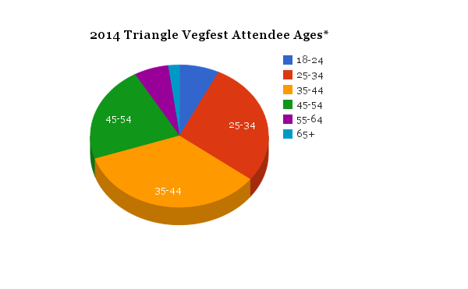
On the Triangle Vegfest Facebook page 69 percent of likes were from residents of the Triangle-area and 95 percent of likes were from North Carolina, but attendees traveled from at least as far as New York.

There were approximately 2 to 2.6 times as many 2014 Triangle Vegfest attendees as Facebook likes.

LESSONS LEARNED - ATTENDANCE

The attendee comments heard by 2014 Triangle Vegfest organizers and volunteers were overwhelmingly positive. The goal of the Triangle Vegfest was to build community around vegan food, goods, and services in the Triangle. With most attendees coming from the Triangle, it seems that this goal was fulfilled.

On the Triangle Vegfest Yelp page the event received 4 stars from two Yelpers whose only complaint was that food ran out early.

http://www.yelp.com/biz/triangle-vegfest-raleigh

For the 2015 Triangle Vegfest, computers will be set up at the welcome table with an attendee survey. Survey respondants will receive a chance to win a prize as an incentive for participation. This will generate a fuller data set.

The 2015 Triangle Vegfest will aim to have more kid-friendly activities as requested by several attendees.

While the outdoor area of the festival was dog-friendly, the indoor areas were not. The organizers will work to ensure that dog guardians will be allowed to visit all areas of the festival either by having a completely dog-friendly area or by having a doggie daycare on site.

Media Coverage

Maggie’s Conscious Vegan Cuisine sent out a press release to dozens of news organization contacts. The Triangle Vegfest planning committee sent a press release to a smaller number of contacts and also posted the release online. The 2014 Triangle Vegfest received coverage by multiple media outlets.

The Independent Weekly wrote a blog post about the festival four days before the event.

http://www.indyweek.com/food/archives/2014/10/15/first-triangle-vegfest-promotes-healthy-food-choices

Local television news station NBC 17 covered the Triangle Vegfest.

http://www.wncn.com/story/26825577/vegfest-encourages-healthy-living-through-better-eating

Time Warner Cable also sent out a videographer who took footage of the festival.

Helene also did an interview on the radio.

LESSONS LEARNED – MEDIA COVERAGE

For the 2015 Triangle Vegfest, the planning committee will send out a press release to a greater number of media contacts. The committee will also work to cultivate relationships with members of the media through Twitter and email to guarantee that the festival will receive coverage in the weeks leading up to the event.

2015 Projections

Who is interested in this report:
Vendors
Sponsors
Vegfest leaders
Attendees
Media

Thanks to:
Lenore Bradford, Jessica Nalbone, members of the planning committee, Gene Baur, Dilip Barman, etc. andrea gunn, dave Baldwin, Lydia chaeasfd, dagmar, James dealto,

The Triangle Vegfest, presented by Piedmont Farm Animal Refuge, was conceived of and organized by Helene Greenberg with help from Alex Lane and a team of planning committee members including, Maitri Acharya, Jen Morris, Janina Knobeloch, Dave Baldwin, and many others. On the day of the event, 20 volunteers also gave their assistance with set up, take down, and maintaining order.

